ΘΕΜΑ 1. ΚΑΤΑΝΟΗΣΗ ΓΡΑΠΤΟΥ ΛΟΓΟΥ
Read the text and decide if each statement (1-10) is True (A) or False (B).
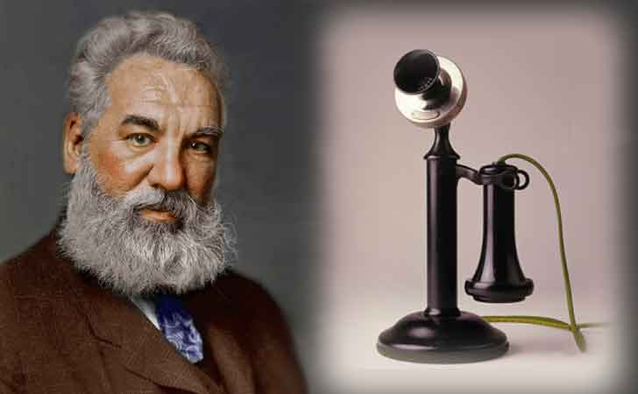
On March 10 1876, in Boston, Massachusetts, Alexander Graham Bell invented the telephone. Speaking through the machine to his lab assistant Thomas A. Watson, who was in the next room, Bell says these famous first words: “Mr. Watson come here, I want to see you”. “Telephone” comes from the Greek word “tele”, meaning “from far away”, and “phone”, meaning “voice” or “voice sound”.
Generally, a telephone is any machine that carries sound over distance. People have used smoke signals, mirrors, jungle drums, pigeons to get a message from one point to another. But a real telephone could not be invented until the electrical age began. The electrical rules needed to build a telephone were known in 1831, but the idea of sending speech electrically was thought in 1854. It wasn't until 22 years later, in 1876, that the idea became a fact. Bell's success came as a direct result of his attempts to improve the telegraph. This had been the traditional means of communication for some 50 years, but with its Morse code, it was limited to receiving and sending one message at a time. The telephone is a shared achievement among many inventors, but Bell's knowledge of the nature of sound and his understanding of music made it easy for him to think of the possibility of sending many messages at the same time.
(Words: 225)
Statements |  | A | B
 |  | TRUE | FALSE
 | Alexander Graham Bell managed to speak through the phone successfully for the first time on March 10, 1876.
 | Alexander Graham Bell spoke through the telephone to his wife.
 | “Telephone” comes from the Greek words “tele” and “phone”.
 | A telephone is a machine that carries images from one place to another.
 | People in the past used smoke signals to send messages at a distance.
 | Scientists knew the electrical rules needed to build a telephone in 1831.
 | A real telephone could be invented only during the electrical age.
 | The telegraph could send many messages at the same time.
 | Alexander Graham Bell invented the telegraph while trying to improve the telephone.
 | Alexander Graham Bell invented the telephone in order to play music to his wife at a distance.

ΘΕΜΑ 2^{α}. ΛΕΞΙΚΟΓΡΑΜΜΑΤΙΚΗ
Match each of the phrases below (11-20) with a word from the box that has a similar meaning (A-J). Use each word only once.
A. | invent | B. | experiment | C. | assistant | D. | communicate | E. | distance
F. | attempt | G. | result | H. | traditional | I. | machine | J. | limited

11. | To try to do or achieve something, especially something difficult.
12. | The amount of space between two places.
13. | A person who helps someone else to do a particular job.
14. | To create something that has never been made before.
15. | A test done in order to learn something or to discover if something works or is true.
16. | To share information with others by speaking, writing, moving your body, or using other signals.
17. | A piece of equipment that uses power to do a particular type of work.
18. | Following or belonging to the customs or ways of behaving that have continued in a group of people or a society for a long time without changing.
19. | For something small in amount or number.
20. | Something that happens or exists because of something else.

